**WEEK – 1 ASSIGNMENT**

**Name:** Priya Garg

**Email:** [priya.26304@gmail.com](mailto:priya.26304@gmail.com)

**AICTE ID:** STU626be0c1e730c1651237057

**Github Repo Link:** [Click Here](https://github.com/PriyaG26/Week1-Sustainable-Supply-Chain-Performance)

**Step1:** The first step is to load the data. This can be done through various ways such as Excel, SQL server, etc. Here, I have imported the data from excel

**Step 2:** The click the “Transform the data” button. This opens new window where we can perform operations on our data. The window looks like below image:

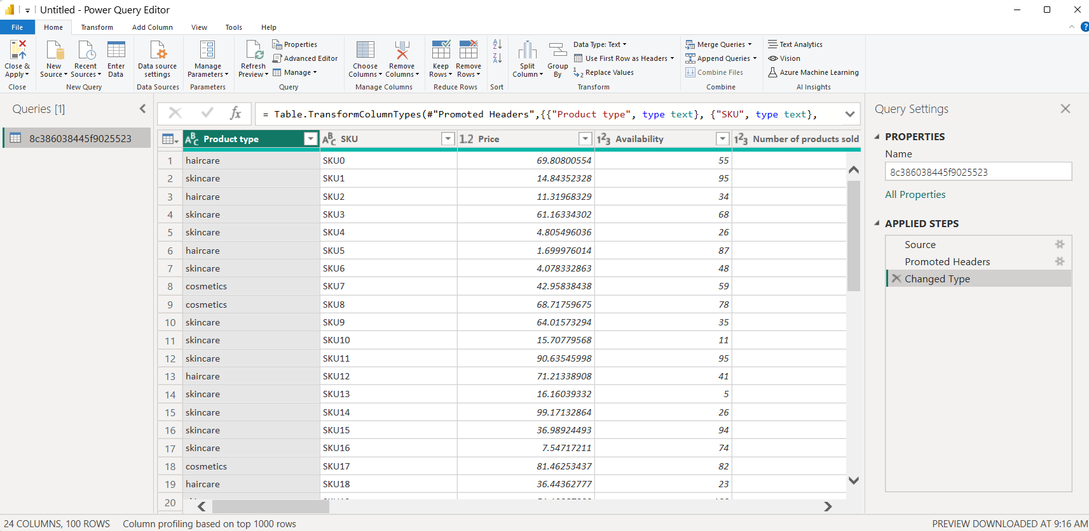

**Step 3:** Right click on the table in the left pane and rename it for better semantics. Again, right click on the table and click on duplicate. Now we can edit his duplicate table without affecting our main table.

**Step 4:** Rename this table. Identify the relevant columns and remove the irrelevant columns. Repeat Step 3 and 4 for every table.

**Inventory Table:** This table contains the columns: Product Type, SKU, Availability, Number of products sold, Customer Demographics, Stock Levels, Lead times, Order Quantities, Lead Time, Revenue generated. Rest all other columns are dropped which are visible in the query.

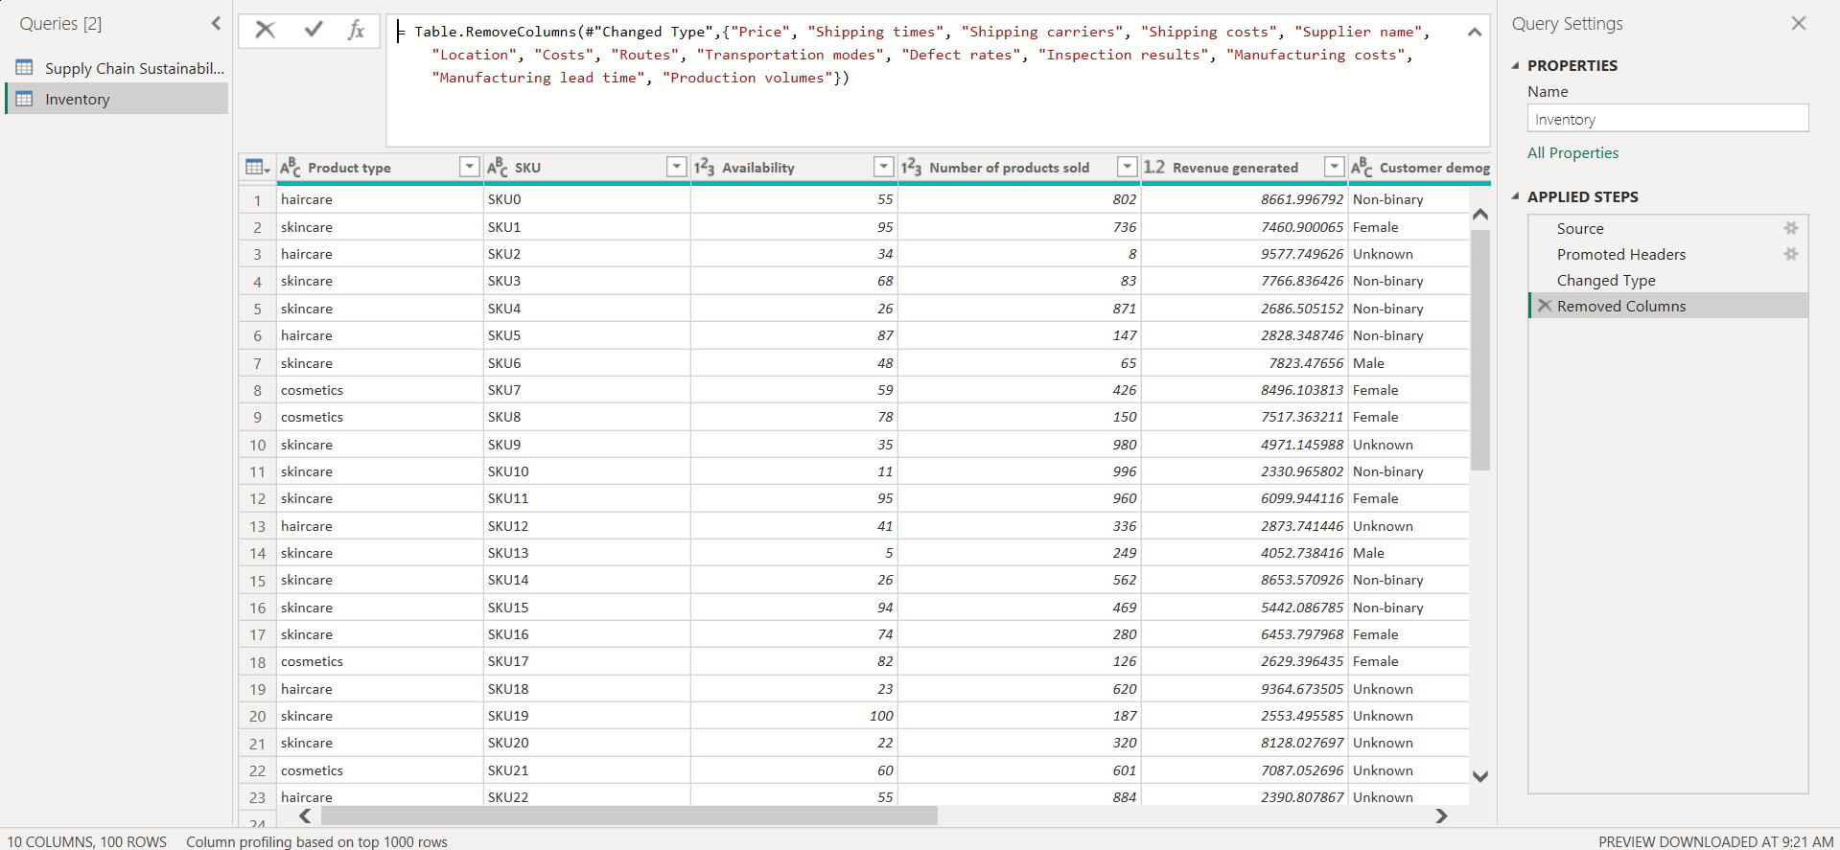

**Manufacturing Table:** This table contains the columns: Product Type, SKU, Production volumes, manufacturing lead time, manufacturing costs, Inspection results, defect rates. Rest all other columns are dropped which are visible in the query.

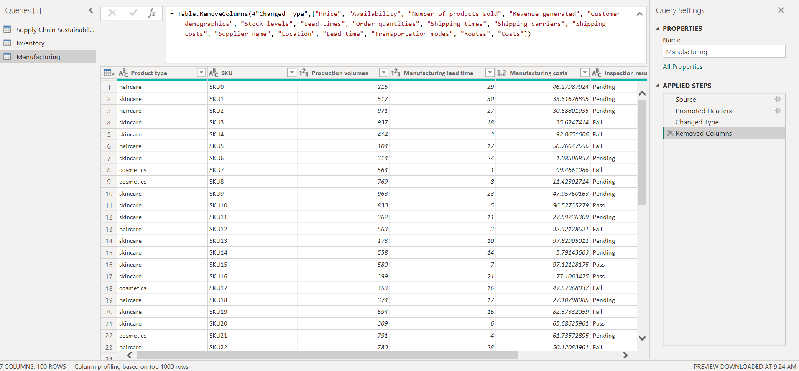

**Supplier Table:** This table contains the columns: Supplier name, location, Lead Time, Transportation models, Routes. Rest all other columns are dropped which are visible in the query.

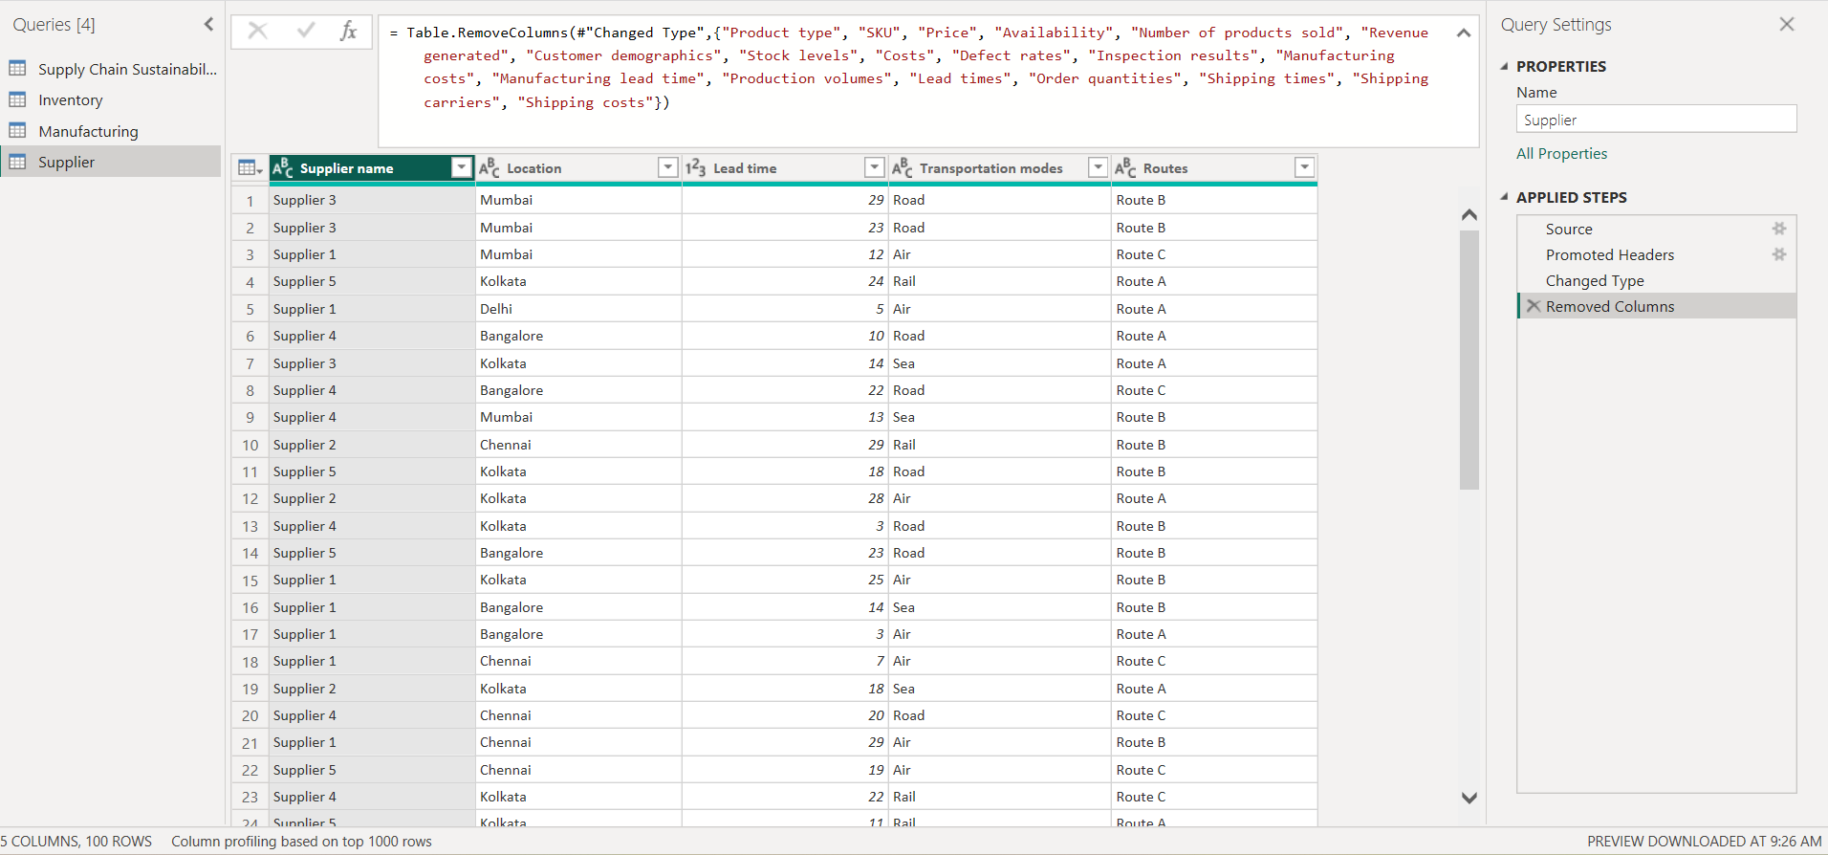

**Inventory Table:** This table contains the columns: Product Type, SKU, Price, Availability, Number of products sold, Revenue generated, Customer Demographics, Stock Levels, Lead times, Order Quantities, Shipping times, shipping carriers, shipping costs, Supplier name, location, Lead Time, Transportation models, Routes. Rest all other columns are dropped which are visible in the query.

